**PROJECT NAME: FLIPKART**



**I.HOMEPAGE**

A homepage is same for all the users throughout. It will display various categories of products. The homepage has the following components included:

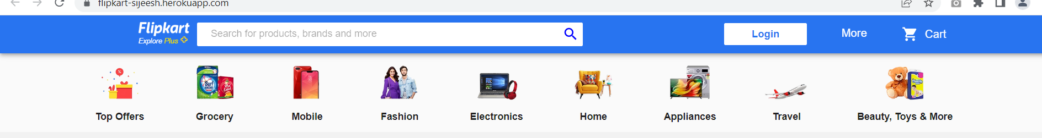

**USER LOGIN**: Everything starts with user log-in. The customer has to fill in like username and password to login.

**SEARCH BAR**: A  search bar, helps the customer to search a product or brand from where they wish to purchase something.

**ADD TO CART:** Once the customer finds a product/products they want to purchase, they can immediately place an order by adding the product to their cart. The cart will display all the necessary details about the product to be purchased and its payment details.

**II. CAROUSEL:** It also includes and the most recognisable brands or promoted discounts and offers, deals of the day, suggested items etc. so that customers take notice of the items.

**II.LISTING PAGE:** A listing page is a page on a website that displays a list of products based on a category or [search query](https://www.dynamicyield.com/glossary/faceted-search/).

* User rating
* Price ranges
* Popular brands
* Discount
* Sort by items

This page will forward the site visitors to the selected [product’s detail pages](https://www.dynamicyield.com/glossary/product-detail-page/).

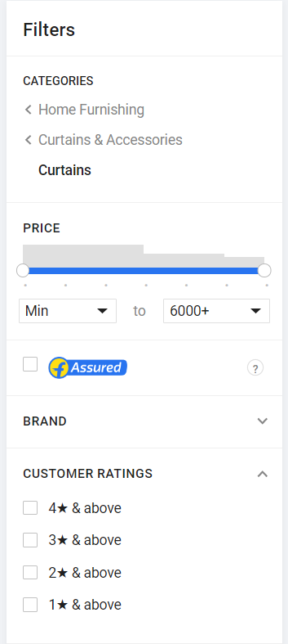 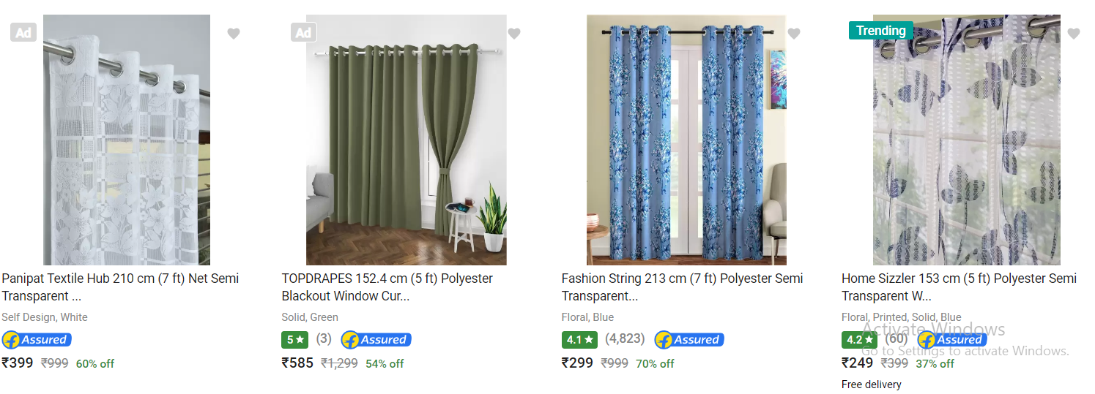

**III.DETAILS PAGE:** A details page is a page on a website that displays the description of the selected product from the listing page. The description of the product like size, color, price, reviews and other related information helps to place order. The order gets added to add to cart when the customer clicks on add to cart button. After the shopping list is finalized, the customer can pay the bill using buy now button.

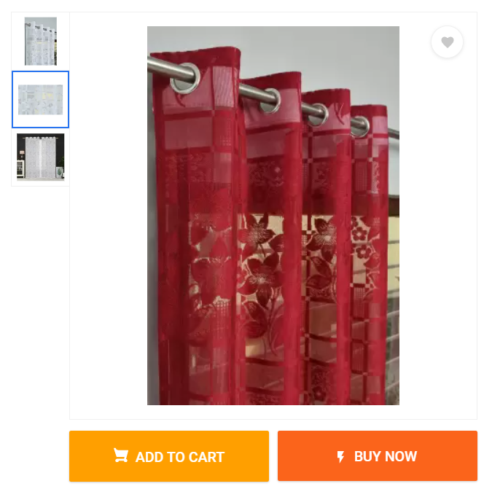

**IV. ADD TO CART:** The**add-to-cart** button is that, which allows customers to choose items to purchase without actually completing the payment. The add-to-cart button allows customers to save items to their cart and allows shoppers to purchase multiple items at one time.

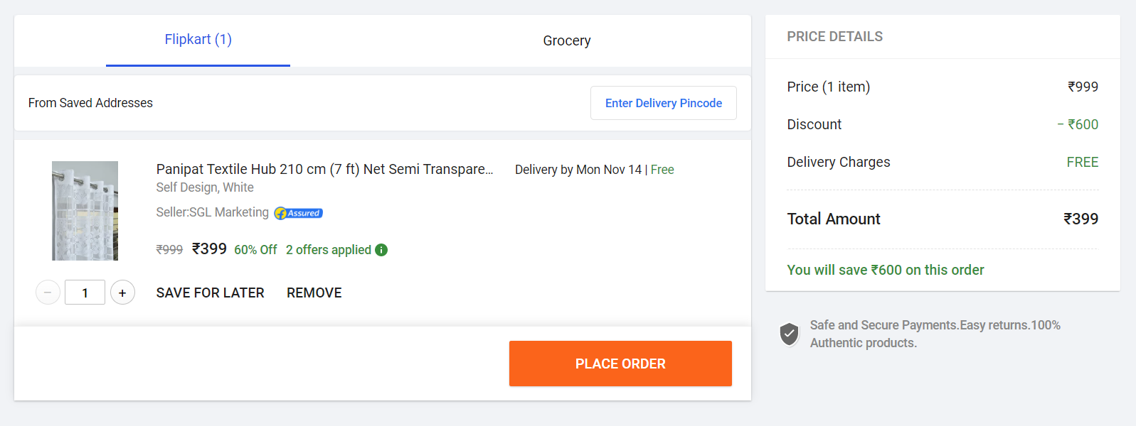

**V.PAYMENT GATEWAY:**

Payment can be done by using the options below:

COD

EMI

Credit card

Debit card